Science of Modern Technology and Public Policy, APHY S100, ENAS S100, PHYS S100.

Session A
Daniel Prober, Prof. of Applied Physics and Physics; daniel.prober@yale.edu https://proberlab.yale.edu
also see https://seas.yale.edu/faculty-research/faculty-directory/daniel-prober

This seminar examines the science behind selected major advances in modern technology. The focus is on the scientific basis of each advance, as well as the technology's resulting impact on society. Students will research individual topics, in consultation with the instructor. Intended for non-science majors. Format is lecture/seminar. On-line in Summer 2022.

This course can be applied towards the Sciences Yale College distributional requirement.

Topics include: nanotechnology; advanced materials; aircraft; space flight; nuclear power, weapons, medical uses; optical systems for communication and medical diagnostics; magnetic-resonance imaging -MRI transistors and integrated circuits; self-driving cars, clean energy and Yale initiatives; renewable energy technologies, and applications in the developing world, new technology for satellite imaging /GPS.

Texts: There is no required textbook; we will provide readings for all the topics and will post lecture notes for each lecture. Yale exhibits some of these advanced technologies, so we will use Yale examples where appropriate, with virtual ‘class trips’.

Background required: Knowledge of high school math, chemistry, and physics is assumed.
Homework: Optional homework help sessions will be held.

Midterm exam: Open book, with a 1-hour time limit, given during class time.

Final paper: Each student will submit an individual paper or do in-class presentation at the end of the term.

Grading:
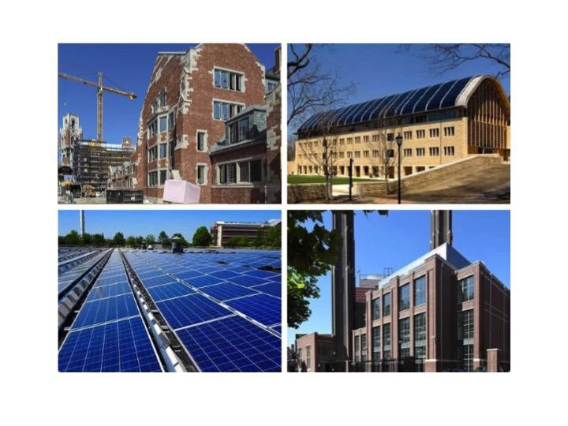
- Homework 30%
- Midterm exam 30%
- Final paper/presentation 30%
- Class participation 10%

Examples of Yale topics we will discuss in
this course; pictures from the Yale campus:
(upper left) a. Yale’s new residential
colleges and energy efficiency b. Kroon Hall,
with solar and geothermal renewable
energy c. Yale power plant, co-generation
d. Yale solar plant

