Eugenics and its Afterlives
ER&M 391/HSHM 455
Draft Course Syllabus, Summer 2022

Professor Daniel Martinez HoSang daniel.hosang@yale.edu

Preface

In the late 1920s, an organization called the American Eugenics Society (AES), led by a prominent set of Yale faculty and administrators, met regularly at its New Haven headquarters at 185 Church Street. There, leading scholars from across the nation would turn to the most advanced research findings in medicine, psychology, economics, sociology, and other disciplines to support their emerging science of “race betterment,” linking the regulation of reproduction to the future health of the nation. Many Eugenicists advocated that involuntary sterilizations of the “unfit,” together with race-based immigration exclusions, were vitally necessary to safeguard the well-being of the nation and its white Anglo-Protestant heritage. Their research and findings were eagerly consumed and championed by colleagues in Nazi Germany, as well as within the many dozens of hospitals, prisons and other state institutions where tens of thousands of Americans were involuntarily sterilized in the early 20th century.
The building housing the AES has long been demolished; their research and findings widely discredited. But the influence and legacy of their work in the academic disciplines has not.
The impact and assumptions of Eugenics with its focus on cultural, intellectual and hereditary hierarchies and its disavowals of domination and power, continues to shape the academic disciplines today. Celebrations of “racial colorblindness,” race neutrality, and even diversity have not displaced these inheritances. These traditions shape research designs in sociology and political science. They constitute the interpretive practices and organization of art history, literary studies, musicology and other humanistic fields. They influence the periodization and privileged regions of study within history, geography, and anthropology. They shape the trajectory of biomedical research, and the organization of subfields and research paradigms in psychology and economics.
Yet an important body of scholarship and critique, evident in the work of figures including W.E.B. DuBois, Toni Morrison, Dorothy Roberts, Eduardo Bonilla Silva, Edward Said, Kimberle Crenshaw, Linda Tuhiwai Smith, Sandra Harding, Charles Mills, Stephen Gould and many others, have contested these traditions, and reimagined the production of knowledge outside of these parochial constraints.

A. Seminar Description
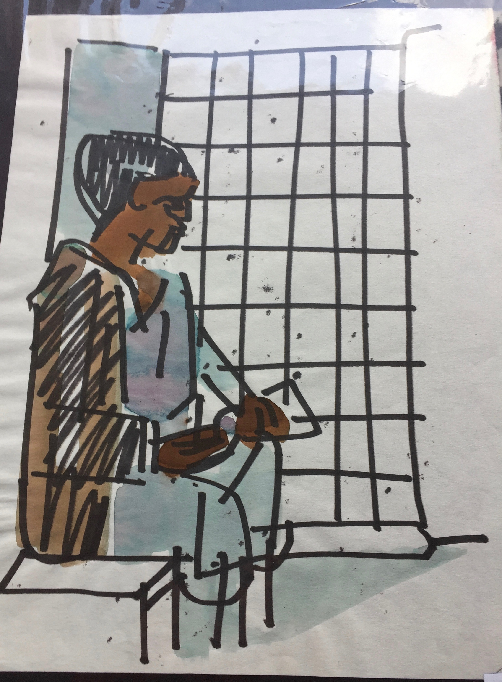
1Sketch of Rosa Parks by Romare Bearden, n.d.; collection of Russel Goings
This seminar, intended for undergraduate students from all disciplines, including the social sciences, humanities, natural sciences, and creative fields, examines how Eugenics and traditions of scientific racism have shaped the university and the academic disciplines.

The texts and themes highlight both the emergence of Eugenics across nearly every academic discipline during their formative periods, and the particular masks, tropes, and concepts that have been used to occlude attentions to these legacies today.

We will make use of the large collection of archives held within Yale Special Collections of key figures in the American Eugenics Society.

B. Readings and required Texts

As the syllabus indicates, most of the weekly readings will be drawn from a combination of scholarly articles and book chapters. The following book is required and is available online:

- Michael Yudell, Race Unmasked: Biology and Race in the 20th Century (Columbia, 2016).

C. Assignments (All of the assignments below must be completed in order to pass the course).

- WEEKLY READING RESPONSE PAPERS. Students will submit a 1-2 page response paper synthesizing the key insights and questions from the readings. The discussion prompts will be provided for each week—they will often be oriented towards students’ respective disciplines and objects of study. These papers must be submitted via Canvas by 5 PM on the day before class. (35% of final grade).
- SEMINAR FRAMING AND FACILITATION. Students will sign up in pairs to provide a framework for the weekly discussion, based on their engagement with the readings and the themes raised in the weekly response papers, and will facilitate a 30 minute discussion in the first part of the seminar. Students will also have rotating roles in preparing discussion questions and contributing to the course Wiki on Canvas (20% of final grade).
- RESEARCH PAPER. Students will produce an original paper for the seminar, 7-10 pages in length, based on archival research conducted in Yale Special Collections or a related digital archive. Details will be provided during the first seminar meeting and during individual meetings with the instructor. (35% of final grade).
- PARTICIPATION AND ATTENDANCE. Attendance is taken every class; advanced reading and participation are critical. Please notify the instructor in advance if you anticipate missing a class meeting. (10% of final grade).

COURSE SCHEDULE

UNIT ONE: THE EMERGENCE OF THE EUGENIC WORLDVIEW

In this unit we will be examining the foundational role of Eugenics in the University and the academic disciplines, including an extended study of Eugenics research at Yale.

DAY ONE: Why are we here? On Eugenics, Racial domination, and the Academic Disciplines

Please read/listen in advance:

- Kimberle Crenshaw, L Harris, D HoSang, and G Lipsitz “Introduction” in Seeing Race Again: Countering Colorblindness Across the Disciplines (UC Press, 2019).
- Toni Morrison, “A Humanist View.” Speech delivered at Portland State University, May 1975, here. Or listen to Morrison deliver the speech here (starts at 7:15 and listen through 43:15).
- Rod Ferguson, “University.” Critical Ethnic Studies, vol. 1, no. 1, 2015, pp. 43–55.

DAY TWO, The 2021 Second International Congress of Eugenics and its Legacies

Readings:

- Henry Osborn. "The second international Congress of Eugenics address of Welcome." Science 54.1397 (1921): 311-313.
- Harry Laughlin. The second International Exhibition of Eugenics held September 22 to October 22, 1921, in connection with the Second International Congress of Eugenics in the American Museum of Natural History, New York. Vol. 1. Williams & Wilkins, 1923.
- Steven Farber. "US scientists' role in the eugenics movement (1907–1939): A contemporary biologist's perspective." Zebrafish 5.4 (2008): 243-245.

WEEK TWO

DAY ONE: Situating Eugenics in U.S. History

Reading:

- Michael Yudell, Race Unmasked: Biology and Race in the 20th Century (Columbia, 2016). (Part 1)

DAY TWO: Eugenics at Yale

Readings:

- Annie L. Cot, "Breed out the Unfit and Breed in the Fit": Irving Fisher, Economics, and the Science of Heredity. The American Journal of Economics and Sociology. Vol. 64, No. 3 (Jul., 2005), pp. 793-826.
- Ellsworth Huntington “The Adaptability of the White Man to Tropical America. The Journal of Race Development. Oct., 1914, Vol. 5, No. 2 pp. 185- 211 Stable URL: https://www.jstor.org/stable/29738039
- Select publications of the American Eugenics Society

UNIT TWO: THE EMERGENCE OF THE EUGENIC WORLDVIEW IN THE ACADEMIC DISCIPLINES

In this unit, we will be “touring” different disciplines, noting the particular conventions, methodologies, frameworks, aesthetic practices and research paradigms that have been influenced by Eugenics. Students will be asked to reflect on the ways that Eugenics has shaped the disciplines in which they have been trained, and to trace connections and articulations across these fields.

WEEK THREE

DAY ONE: Reproductive Regulation and Control

Reading:

- Alexandra Stern. Eugenic Nation: Faults and Frontiers of Better Breeding in Modern America (UC Press, 2015)-Selections

DAY TWO: The Social Sciences and Economics

Reading:

- Thomas Leonard, Illiberal Reformers: Race, Eugenics, and American Economics in the Progressive Era (Princeton, 2017)—Selections.

WEEK FOUR

DAY ONE: Music and the Creative Arts

Readings:

- Julia Eklund Koza, "Destined to Fail": Carl Seashore’s World of Eugenics, Psychology, Education, and Music (Michigan, 2021)-Selections

DAY TWO: Genomics and the Natural Sciences

Readings:

- Robert Guthrie, “Introduction” in Even the Rat Was White: A Historical View of Psychology. 2nd Edition. (Pearson, 2003)
- Michael Yudell et al. “Taking race out of human genetics. Engaging a century-long debate about the role of race in science.” Science, February 5, 2016. (351: 6273).
- Dorothy Roberts."Race, gender, and genetic technologies: A new reproductive dystopia?." Signs: Journal of Women in Culture and Society 34, no. 4 (2009): 783-804.

UNIT THREE: TOWARDS NEW FUTURES

In the final unit, we will be examining various intellectual traditions, including women of color feminism and indigenous and anti-colonial scholarship that has challenged the precepts of racial colorblindness and produced alternative forms of knowledge and engaged scholarship.

WEEK FIVE

DAY ONE: Anti-Racist Uptakes During the Eugenic Era

Reading:

- Ayah Nuriddin,“Engineering Uplift: Black Eugenics as Black Liberation” in Nature Remade: Engineering Life, Envisioning Worlds (Chicago, 2021).
- WEB DuBois et al Black Lives 1900: W.E.B. Du Bois at the Paris Exposition. Redstone Press (2019).
- Kim TallBear. "Indigenous bioscientists constitute knowledge across cultures of expertise and tradition: An Indigenous standpoint research project." In: Re:Mindings: Co-Constituting Indigenous, Academic, Artistic Knowledges (pp. 173-191). Uppsala: The Hugo Valentin Centre, Uppsala University.

DAY TWO: Seminar Conclusion

Reading:

- Milton Reynolds, “Shifting Frames: Pedagogical Interventions in Colorblind Teaching Practice,” in Seeing Race Again.

Student presentations of research projects
_________________________________________________________________________________

Other Course Policies

- CLASSROOM CONDUCT & CLIMATE. We are all accountable to create a climate of mutual respect and engagement in the classroom. While differences of opinion, perspective and analysis are important and will be encouraged, common courtesy as well as University policy prohibit personal attacks and discriminatory conduct.
- ATTENDANCE. You are expected to arrive on time and stay for the entire class and participate fully in class discussions. Please contact the instructor in advance to request an accommodation for any anticipated absences.
- ACADEMIC INTEGRITY. All work submitted in this course must be your own and produced exclusively for this course. The use of sources (ideas, quotations, paraphrases) must be properly acknowledged and documented. Penalties for plagiarism can include a failing grade for the course. Guidelines on proper citation practices and avoiding plagiarism can be found here: http://writing.yalecollege.yale.edu/advice-students/usingsources/ and here: http://ctl.yale.edu/writing/using-sources/understanding-and-avoiding-plagiarism/what-plagiarism.
- ACCESSIBILITY. Your success in this class is important to me. We will all need accommodations because we all learn differently. If there are aspects of this course that prevent you from learning or that form barriers to your inclusion, please let me know as soon as possible. Together we’ll develop strategies that can enable you to succeed in the course. I encourage you to visit Student Accessibility Services to determine how you could improve your learning as well. If you need official accommodations, you have a right to have these met. The SAS is located at 35 Broadway, Room 222 and can be reached at 203-432-2324.
- SYLLABUS CHANGES: Changes to the syllabus may be made during the term and will be announced in class and on Canvas.
- LATE SUBMISSION POLICY: Generally, a letter grade will be deducted for any assignments submitted after the due date.
- DIGITAL RESOURCES: Relevant class materials posted on Canvas are indicated. Students are expected to check the course site regularly.

